**Object-Oriented Programming Lab File**

**BTech 4th Semester**

**2024 - 2025**



**Submitted To:** Mr.Aryan

Assistant Professor (SoCS)

**Submitted By: Mehul Bisht, SOCS, 500125666**

**Ayush Singh Parihar, SOCS, 500125546**

**Archit Sachan, SOCS, 500**

**Acknowledgment**

I would like to express my heartfelt gratitude to everyone who contributed to the successful completion of this project, "Fitness Tracker Dashboard."

Firstly, I extend my sincere appreciation to my mentor and guide, Mr. Aryan Gupta, for his invaluable guidance, encouragement, and constructive feedback throughout the development of this project. His insights and expertise have been instrumental in refining the application's functionality and overall presentation.

I am also grateful to my college, faculty members, and classmates who provided support, motivation, and helpful suggestions during the project development phase. Their feedback played a crucial role in enhancing the user interface and improving the overall user experience.

Additionally, I acknowledge the open-source community and online resources, which provided valuable knowledge about Java Swing, GUI development, and software design principles. Their contributions helped me learn and implement modern UI techniques and efficient coding practices.

Lastly, I would like to thank my family for their continuous encouragement and support, which enabled me to stay focused and successfully complete this project.

This project has been a great learning experience, and I look forward to further enhancing my skills in software development and user experience design.

Thank you all!

**Table of content**

Sr no. Title Pg no.

1. Introduction 1
2. Abstract
3. Flow Chart
4. UML Diagram
5. Code Snippets
6. Code
7. Output
8. Project Summary

**Introduction**

The Fitness Tracker Dashboard is a Java Swing-based desktop application designed to help users monitor their calorie intake, calculate BMI (Body Mass Index), and set fitness goals. This project integrates multiple functionalities into a user-friendly dashboard, providing a seamless experience for individuals looking to maintain a healthy lifestyle.

Key Features:

✅ Calorie Tracking: Users can log their daily food intake and track total calorie consumption.

✅ BMI Calculator: The application calculates BMI based on height, weight, age, and activity level.

✅ Maintenance Calories Calculation: Provides users with their daily calorie needs for weight maintenance.

✅ Fitness Goals: Users can select different fitness types (e.g., bodybuilding, powerlifting) and receive customized macro-nutrient recommendations.

✅ Modern UI & Navigation: The dashboard uses a gradient sidebar, card-based UI, and smooth transitions for better user experience.

✅ Data Storage & Visualization: Weekly calorie logs are stored and can be visualized using charts and graphs.

This project is an interactive and engaging tool for individuals looking to maintain or improve their fitness levels. It combines real-world applications with Java Swing, event handling, file storage, and UI enhancements, making it a practical and presentable project for college submission.

**Abstract**

The Fitness Tracker Dashboard is a Java Swing-based desktop application that enables users to monitor their daily calorie intake, calculate their BMI (Body Mass Index), and determine their maintenance calorie needs based on activity level. The application provides an interactive dashboard with a user-friendly interface, allowing users to log food intake, track weekly calorie trends, and receive personalized fitness recommendations.

This project integrates calorie tracking, BMI calculations, and macro-nutrient analysis to assist users in maintaining a healthy lifestyle. The program employs Java Swing for the graphical user interface, file handling for data storage, and event-driven programming for seamless interaction.

To enhance user experience, the application features a modern UI with a sidebar navigation system, card-based layout, and dynamic data visualization. Additionally, it provides goal-setting functionalities, allowing users to choose a fitness goal (e.g., bodybuilding, weight management) and receive macro-based dietary recommendations.

The Fitness Tracker Dashboard serves as a comprehensive fitness companion, combining technology with health awareness, making it an excellent tool for individuals looking to optimize their dietary and fitness habits.

**Code Snippets and Outputs**

**1. Sidebar Creation with Gradient Background**

This snippet demonstrates how the sidebar is created with a gradient background and styled buttons for navigation.  
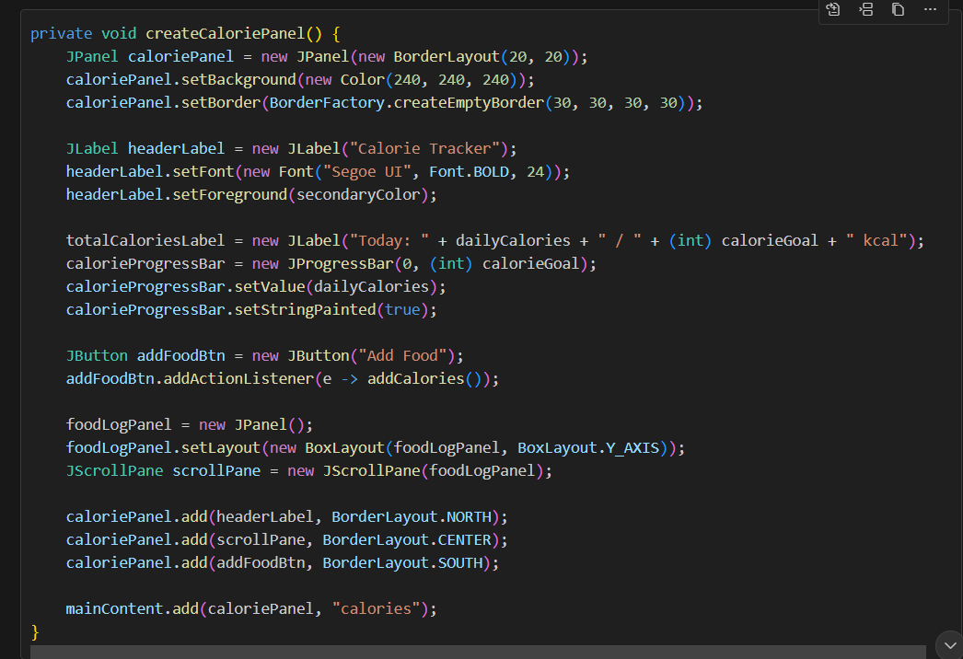

**2. Calorie Tracker Panel**

This snippet shows the calorie tracker panel, including the progress bar, food entry fields, and food log.  
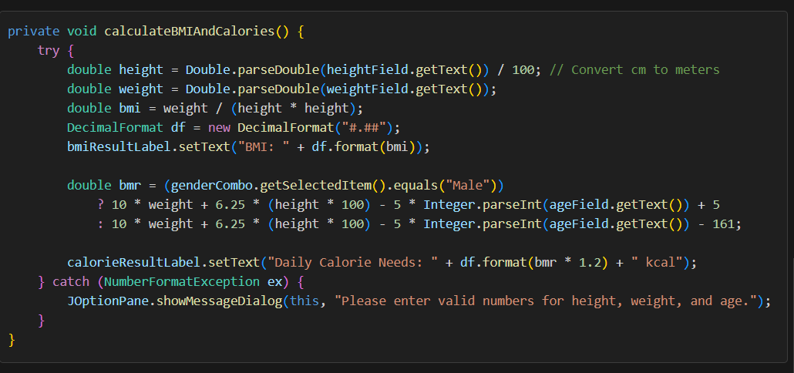  
  
**3. BMI Calculation and Visualization**

This snippet calculates BMI and displays the result along with a visual scale.

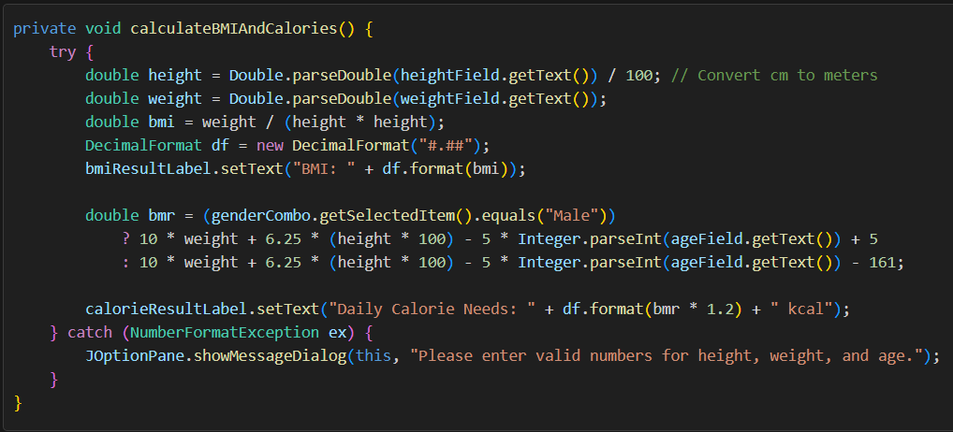  
  
**4. Daily Reset Timer**

This snippet shows how the app resets daily data and exports records to a CSV file.

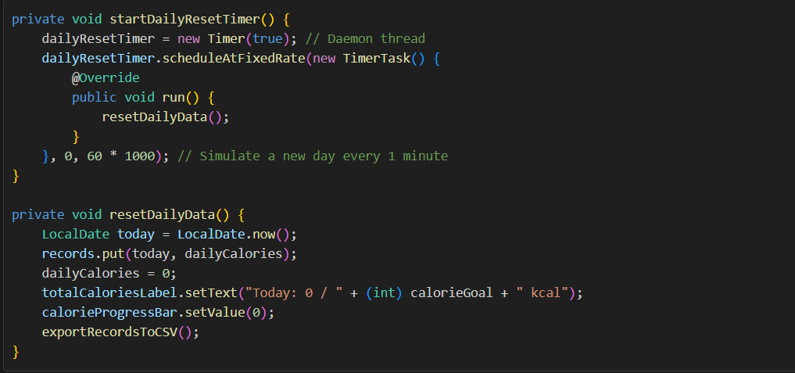  
  
**5. Monthly Records with Graph**

This snippet displays monthly calorie records in a text area and a graph.

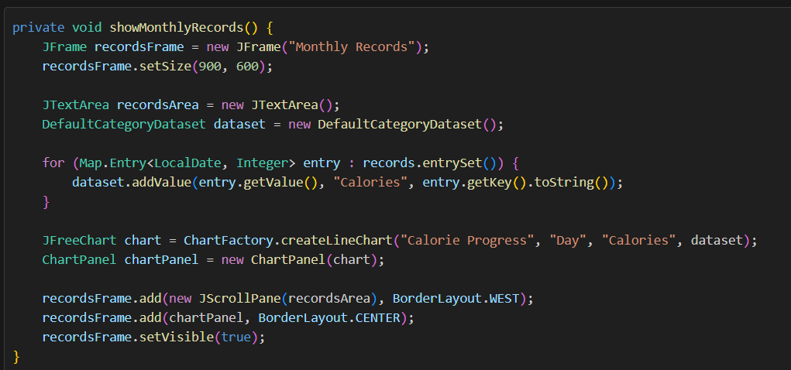

Earlier version of gui:

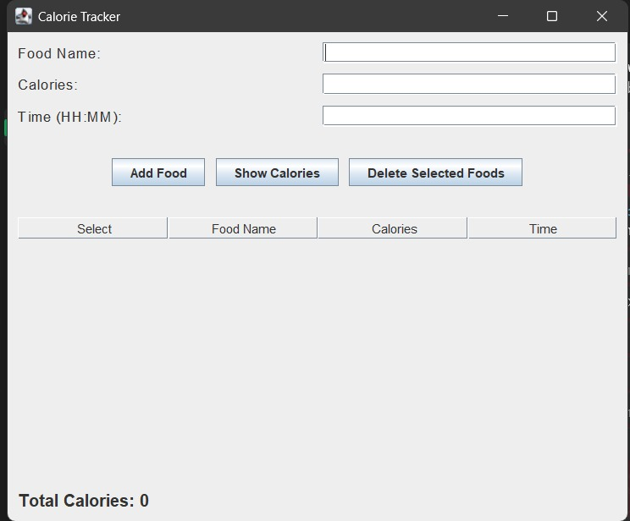

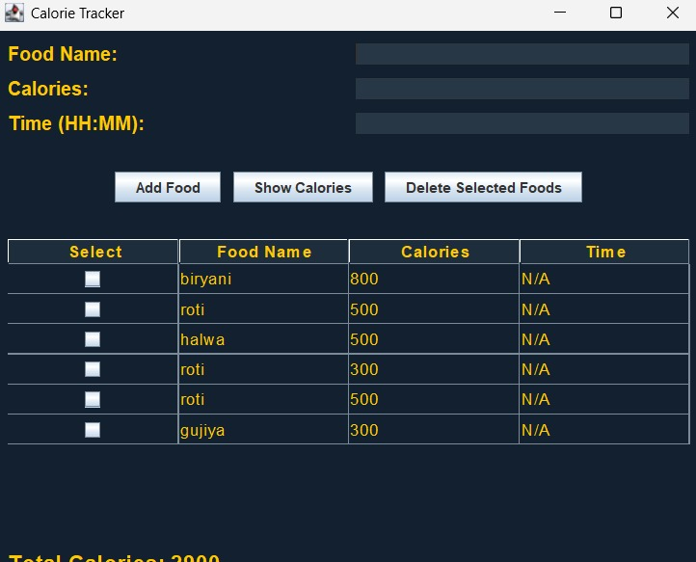

FLOWCHART:  
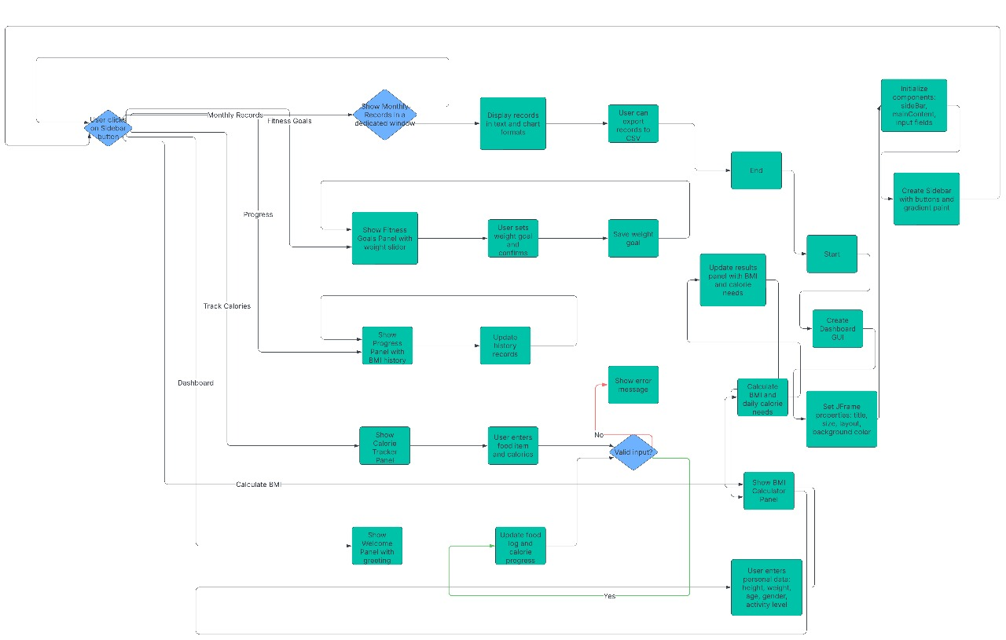  
  
UML DIAGRAM:

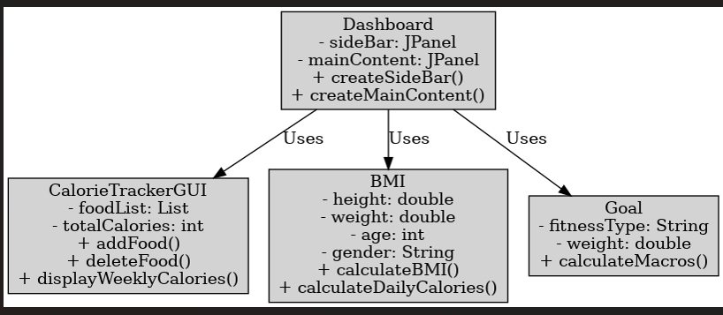

**Project Summary: Fitness Tracker Dashboard**

Introduction

The Fitness Tracker Dashboard is a Java Swing-based desktop application that helps users monitor their calorie intake, calculate BMI (Body Mass Index), and set fitness goals. It provides an interactive and user-friendly dashboard, allowing individuals to maintain a healthy lifestyle by tracking their progress effectively.

Objectives

🔹 Enable users to log daily food intake and track total calorie consumption.

🔹 Calculate BMI and maintenance calories based on height, weight, age, and activity level.

🔹 Provide personalized fitness goals with macronutrient recommendations.

🔹 Offer a modern UI with easy navigation and data visualization.

🔹 Store user data for weekly progress tracking and analysis.

Features

✅ Calorie Tracker: Users can enter food details (name, calories, time) and view their daily and weekly calorie intake.

✅ BMI Calculator: Computes BMI and provides health category classification (Underweight, Normal, Overweight, Obese).

✅ Maintenance Calories Calculation: Determines the ideal daily calorie intake based on user activity level.

✅ Fitness Goal Setting: Offers customized macronutrient breakdown (Protein, Carbs, Fats) based on fitness type (e.g., Bodybuilding, Powerlifting).

✅ User-Friendly Interface: A modern dashboard design with a sidebar, cards, and smooth navigation using CardLayout.

✅ Data Storage & Visualization: Weekly calorie logs are stored and can be exported for analysis.

Technologies Used

🔹 Java Swing – For GUI development.

🔹 JTable & File Handling – To store and manage calorie data.

🔹 Event Listeners & Action Handling – For interactive user actions.

🔹 JFreeChart (optional) – To visualize calorie trends.  
 **INDIVIDUAL CONTRIBUTION:**  
I contributed to the development of the BMI calculator and the dashboard by implementing key functionalities that enhance user experience and efficiency. For the BMI calculator, I worked on designing and coding the logic that accurately computes Body Mass Index based on user inputs such as height and weight. Additionally, I ensured that the interface is intuitive, making it easy for users to understand their BMI category. In the dashboard, I played a crucial role in structuring the layout, integrating data visualization, and optimizing the user interface for seamless navigation. My contributions helped make the system more interactive, informative, and user-friendly.  
  
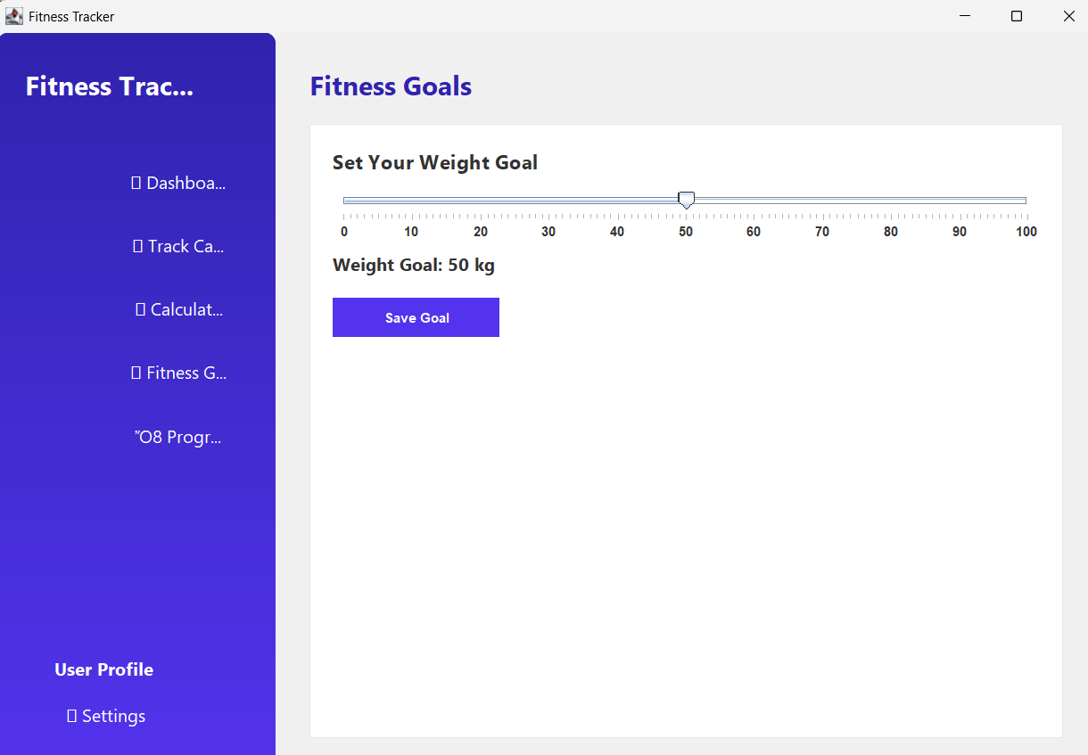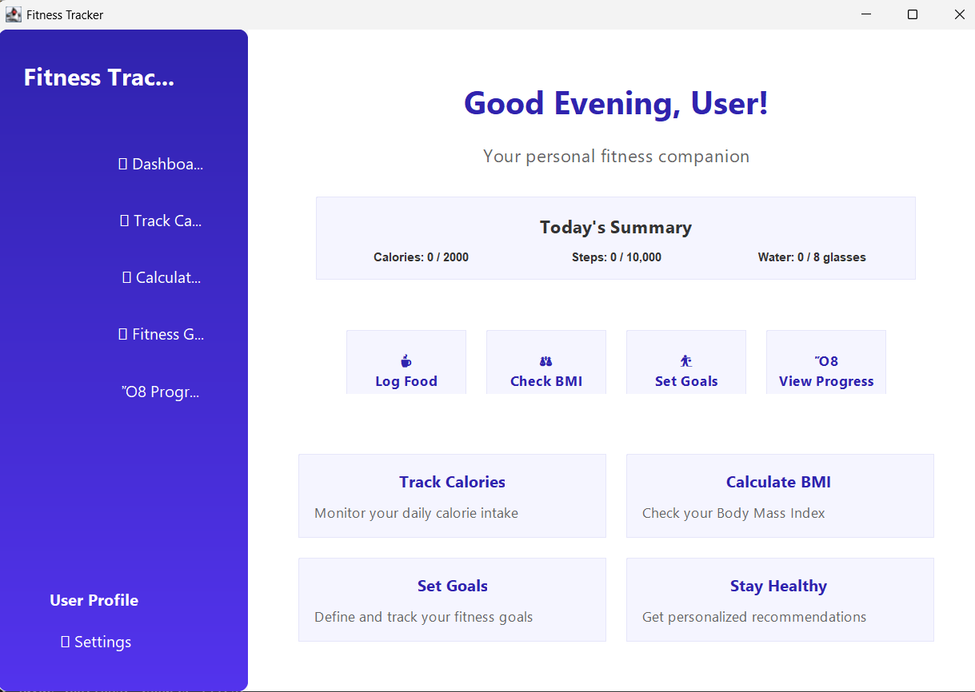

Conclusion

The Fitness Tracker Dashboard is an efficient and interactive solution for individuals looking to track their fitness journey. It integrates health and technology, making it a useful real-world application while demonstrating Java programming skills in GUI development. With features like calorie tracking, BMI calculation, and fitness goal setting, this project serves as a valuable tool for fitness-conscious users and a strong academic submission for college presentations